OMB Instructor Resources Folder Guide

We hope this document will answer any questions you may have about how to access the instructor materials used to present OMB classes to your apprentice students.

All OMB classes and lesson plans are stored on Google Drive. This is a program where shared information is stored. The OMB Instructor Resources folder can be accessed by all OMB Instructors. This guide will briefly show you how to download your materials. You do not have to have a Google email account to access Google Drive.

Please revisit this folder and download a fresh version of each class and lesson plan at the start of every year. We will be making edits to the classes based on your feedback this year, so content may be changing.

How to find your way around Google Drive
- To access Drive, hover the cursor over the link. Hold down the control key and click on the link.
Click here to open the OMB Instructor Resources folder

- The Google Drive window will look like this. Each folder’s title corresponds to an individual class session.
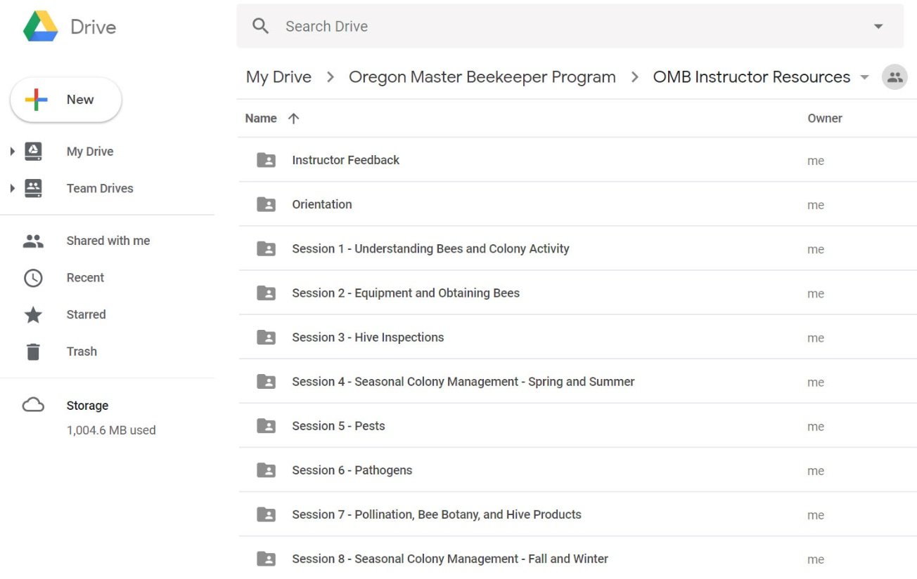
- Once you click inside the folder of your choice, you will see icons for the class presentation PowerPoint file and lesson plan Microsoft Word file.

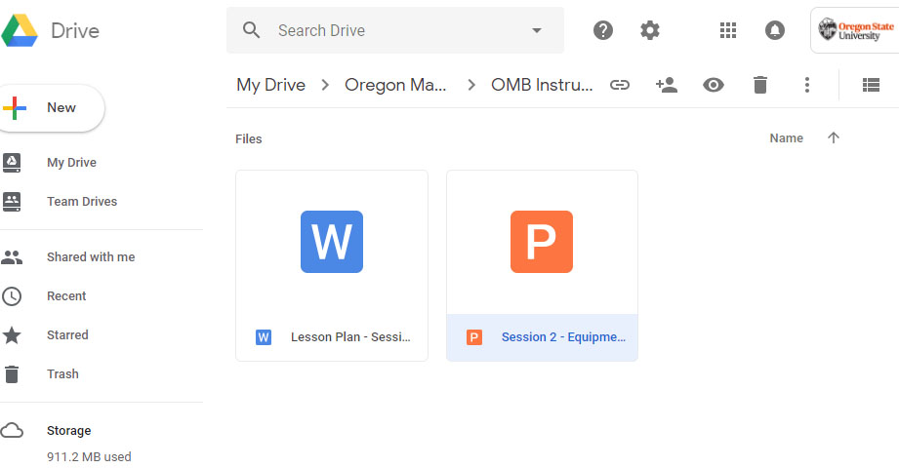

- To download each file, select the icon you wish to download, and click the button with the three vertical dots. Select download.

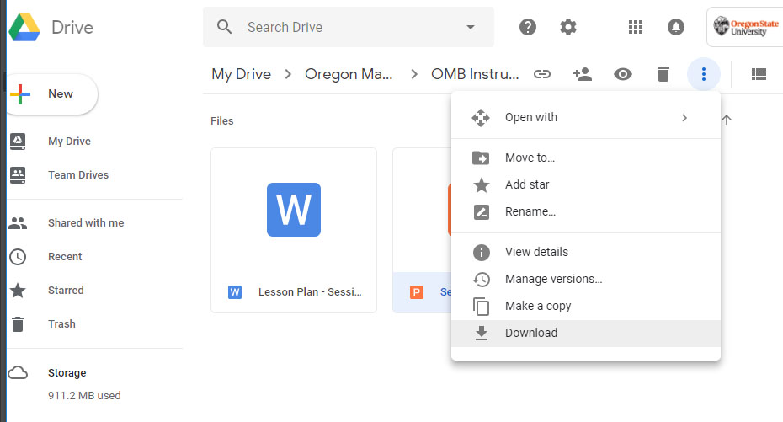
- Google Drive will then download a copy of the file for you. Access this by clicking on the new link that appears at the bottom of your screen.

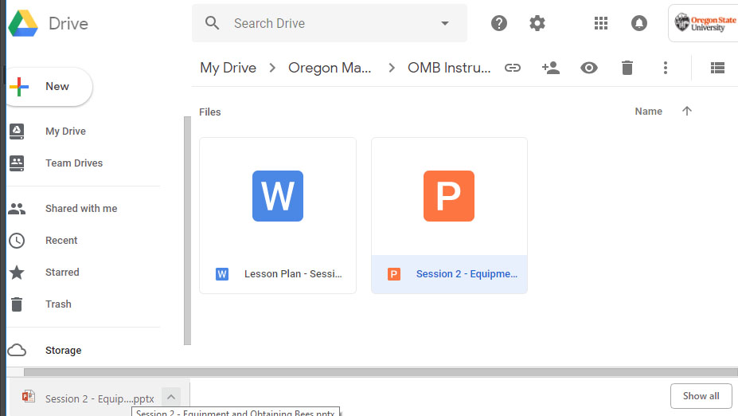

- When you click on the new link, the PowerPoint or Word document will open on your screen. You can then save this file to your computer for permanent access.
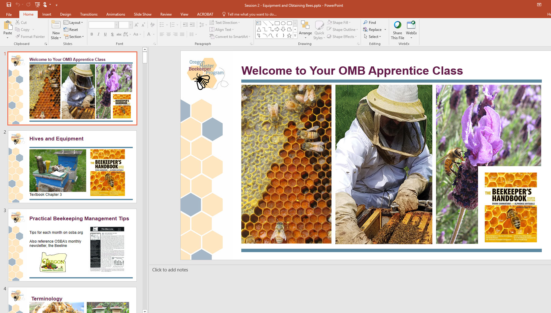
- We would love your feedback! There is a folder title ‘Instructor Feedback’ that is intended to be a repository for notes, slides, images, etc. that you think would be good to add to our presentations.

- To upload files (jpg, pdf, Word documents, PowerPoint slide, etc.), make sure you are inside the ‘Instructor Feedback’ folder. Click on New, then follow the prompts to upload files. We’ll take it from there!

